**Leader Overview**



**Volume Overview**

**Pursue Jesus**

*Jesus’ offer is remarkably clear: If we look for Jesus, we’ll find Him. He’s not hiding from us, but closely connecting with Him does take us being intentional. We’re called to follow Him, to pursue Him. In this volume, we’ll look at how individuals pursued Jesus through the challenges of their circumstances. Pursuing Jesus is not only a mental exercise for personal growth, but it also means living out our faith in tangible ways: showing up, listening carefully, receiving grace, and trusting Him.*

**Session Overview**

**Trust Him**

*In this* **Live** *session, kids will learn that they can trust Jesus when they’re afraid. Like the disciples in a boat on the Sea of Galilee, we all have times when we feel as if we’re being tossed in a storm of sorts. But Jesus will come close to us in those moments. Like Peter, we can call out to Jesus when we need help, and we can trust Him to act in powerful ways on our behalf.*

**Bible Lesson**

Peter Walks toward Jesus on the Water

[Matthew 14:22–33](https://ref.ly/logosref/Bible.Mt14.22-33)

**Faith Fact**

I can trust Jesus if I’m afraid.

**Faith Verse**

[Jeremiah 29:13](https://ref.ly/logosref/Bible.Je29.13) (NLT)

“If you look for me wholeheartedly, you will find me.”

**Preparing for the Session**

**Leader Preparation Time: 20–25 Minutes**

|  |
| --- |
| ***You Will Need***  ***Large Group***  *• Bible*  *• Worship songs (Song suggestions: “Shine a Light” by Kids on the Move; “Available” by Elevation Worship; “Fresh Chance” by River Valley Worship [lyric video])*  *• For groups not using a phone or tablet only, add:*  *• Projector or TV*  *• Laptop*  *•* ***Faith Fact Slide***  *•* ***Faith Verse Video*** *or* ***Slide***  *•* ***Bible Lesson Video***  *•* ***Teaching Point Slides 1–3***  *• Paper towels or wet wipes*  *• Table with plastic tablecloth*  *• Three brown paper bags*  *• Gallon-size zipper plastic bags for items below that may leak*  *• Something soft (plush toys, cotton balls, etc.)*  *• Something slimy (liquid soap, slime, raw eggs, etc.)*  *• Something smelly (sardines, vinegar, etc.)*  ***Small Group***  *• Bibles for kids in the group to share*  *• Painter’s tape*  *• Smartphone or timer*  *•* ***Small Group Activity Page****, one per kid*  *• Pencils or pens, one per kid*  *To access session content and videos from a computer, visit:* [***BibleEngagementProject.com/downloads***](https://bibleengagementproject.com/downloads) |
| ***Getting Ready***  ***Large Group***  *• Download videos and slides if needed.*  *• Select worship song(s) and have them ready to play.*  *• Read the Bible Lesson Scripture to prepare for Teaching Time.*  *• Put any items that may leak into a gallon-size plastic bag.*  *• Place one item inside each of the paper bags, then fold closed the top of each bag.*  *• Set up the table at the front of the meeting area and cover it with a plastic tablecloth.*  *• Line up the bags on the table from least scary to touch to most scary.*  ***Small Group***  *• Tape twelve lines (each about 18 inches long) on the floor. Space the lines so they are a kid-sized leap apart.*  *• Optional: Write each word of the Faith Verse and the reference on a strip of tape.*  *• Print copies of the* ***Small Group Activity Page****, one per kid.*  ***First time leading* Live *for Kids? Check out the* [Facilitator Guide](https://0b769b0ed3569ef9d18b-f88d8272f61086866d50d048b43ef630.ssl.cf2.rackcdn.com/sites/biblengagementproject/Listen_Facilitator_Guide.pdf).** |

**Large Group**

**30 Minutes**

*See what’s needed at the beginning of the session.*

**Introduction**

I’m so excited you’re here! Today, we’re learning about another person in the Bible who was pursuing Jesus. It’s such a fun story because this person walks somewhere really amazing!

I’ve got a question for you before we get started. What’s the most unusual surface you’ve ever walked on? *(Allow responses.)* I can’t wait for you to find out later where our Bible character walked!

**Faith Fact**

Here’s another clue about our Bible story: Someone is afraid but realizes we’re never alone when we’re following Jesus. That reminds me of our Faith Fact today: **I can trust Jesus if I’m afraid**.

• *Show the* ***Faith Fact Slide.***

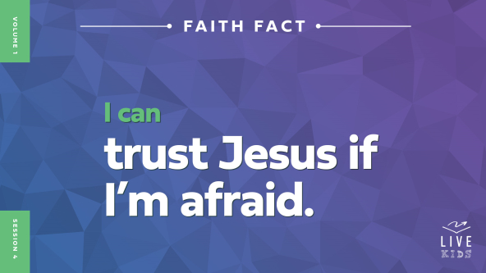

Everyone say it with me. **I can trust Jesus if I’m afraid.** Great job! Now say it while you’re jumping up and down. **I can trust Jesus if I’m afraid.** Keep jumping, and show me your best scared face. Say it one last time. **I can trust Jesus if I’m afraid.** That was super!

**Game**

**Fear Factor**

|  |
| --- |
| ***You Will Need***  *• Paper towels or wet wipes*  *• Table with plastic tablecloth*  *• Three brown paper bags*  *• Gallon-size zipper plastic bags for items below that may leak*  *• Something soft (plush toys, cotton balls, etc.)*  *• Something slimy (liquid soap, slime, raw eggs, etc.)*  *• Something smelly (sardines, vinegar, etc.)*  ***Getting Ready***  *• Put any items that may leak into a gallon-size plastic bag.*  *• Place one item inside each of the paper bags, then fold closed the top of each bag.*  *• Set up the table at the front of the meeting area and cover it with a plastic tablecloth.*  *• Line up the bags on the table from least scary to touch to most scary.* |

We’re going to play a game called “Fear Factor.” Let’s see who is fearless in our group today. You’ll prove you’re fearless by coming up front and sticking your hand in one or more of these bags. But here’s the catch: You don’t know what’s in the bags!

• *Select kids who volunteer to participate. Make sure at least one volunteer will be expressive with their reactions.*

Okay, volunteers, how are you feeling about touching the mystery items in these bags? *(Allow responses.)* It’s time to see how brave you are. The bags are in order from sort of scary to “Are-you-sure-you-want-to-put-your-hand-in-there?” scary! Your job is to overcome your fears and tell us what’s in these bags. After our fearless volunteers have described what they felt, the rest of us will guess what’s inside each bag. Let’s play!

• *Direct the volunteers to take turns placing their hands in the first paper bag.*

• *After they’ve described what they felt, let the other kids guess what’s in the bag.*

• *Repeat with the second and third bags.*

• *After the volunteers have felt the contents of the last bag, give them paper towels or wet wipes to clean their hands.*

Our volunteers were so brave! Thanks for overcoming your fears! This game didn’t have winners or losers, but our volunteers showed how brave they are. They didn’t let their fear keep them from doing something scary even though they didn’t know what they might find. Great job!

• *Ask the volunteers to return to their seats.*

Has being afraid ever stopped you from doing something you really wanted to do. *(Group response)* I’d like one or two people to tell us about a time fear stopped you from doing something you really wanted to do. *(Allow responses.)*

Sometimes fear can freeze us in place or make us want to escape the situation. But when we start following Jesus, we learn how to trust Him and we get braver. Jesus can help us push past the things that make us afraid. We’ll talk more about that, but first let’s do something that isn’t scary at all.

**Worship**

It’s time to sing some songs and worship Jesus! Who’s ready to worship Him today? *(Group response)* Let’s sing together.

• *Lead the kids in singing one or two praise songs. See suggestions at the beginning of the session.*

**Bible Lesson**

What a wonderful time of worship! We’re about to find out what Jesus will say to us through our Bible story today. But first, let’s pray.

**Prayer**

|  |
| --- |
| *Dear Jesus, thank You for giving us a place to get together and worship You. Help us learn from the Bible how we can trust You even when we’re afraid. Open our heart and mind to what You have for us today. Amen.* |

**Video Intro**

Let’s check in with Dash. Just before we watch the video, let’s see if you know the answer to the question I asked at the beginning. Our Bible character walked on a very unusual surface. Shout out what you think it is. *(Group response)* Let’s find out.

• *Play* ***Bible Lesson Video****.*

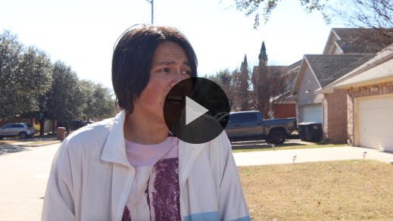

**Bible Story**

**Peter Walks toward Jesus on the Water**

Were you right about the place Peter took a walk? *(Group response)* That video was a great setup for what’s coming next. We know we’re learning about fear and trust. We know both Jesus and Peter walked on water. So now, let’s dive in and see what it’s all about.

**Teaching Time**

When today’s Bible story happened, Jesus had just fed thousands of people next to a lake. He had healed lots of people too. Jesus sent the crowd home, and then it was time to send the disciples away so He could spend some time praying alone. How many disciples did Jesus have? *(Allow responses.)* Correct! He turned to His twelve disciples and told them to get in a boat and head to the other side of the lake. Let’s see what happened next. Grab your Bible or pull up a Bible app on your device. Turn to [Matthew 14:22–33](https://ref.ly/logosref/Bible.Mt14.22-33).

• *In order to keep Large Group time moving along, we recommend that the leader reads the Scripture portions aloud.*

• *Optional: Remind the kids to mark this place with a bookmark, so they can read it on their own at home.*

**1. Even Jesus needed time to pray.**

• *Show the* ***Teaching Point 1 Slide.***

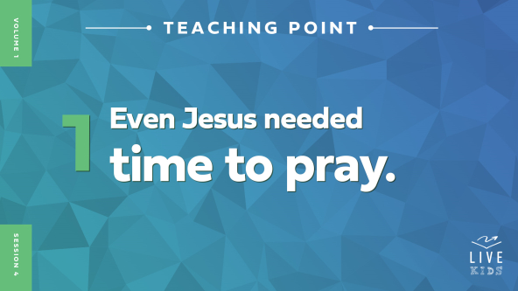

• *Read* [*Matthew 14:22–23*](https://ref.ly/logosref/Bible.Mt14.22-23)*.*

So Jesus went to the hills alone to pray, while the disciples left in a boat. This first part of our story might not seem super important, but it really is. Jesus was showing us that even He, the Son of God, needed a quiet place to pray. He needed to spend time alone talking to God, His Father. You see, earlier in the day, Jesus had heard that His relative, John the Baptist, had been killed. Jesus was probably sad. Then, He had spent hours healing sick people and doing a miracle to feed the crowd. Jesus was probably tired. He also knew what was about to happen in His own life. Jesus needed God’s strength. It was time for Him to get away from everyone else and pray.

It’s important for each of us to have a quiet place where we can pray also. Sometimes life makes us sad or tired and we need God’s strength. Maybe a kid at school is mean to you or you’re having trouble with math or your parents are arguing a lot. Jesus will be there for you no matter what you’re facing. One way we can connect with Him is through prayer. When we tell Jesus what’s wrong and listen to His voice, we can find peace. He helps us get through scary things when we trust Him.

Let’s get back to our story. It was getting dark. Jesus was praying up in the hills. The disciples were in a boat sailing across a lake. How many of you have ever been on a boat? Raise your hand. *(Group response)* How many of you have ever been on a boat at night when it was really dark? Raise your hand. *(Group response)* Let’s keep reading.

**2. We can set our fear aside and trust Jesus.**

• *Show the* ***Teaching Point 2 Slide.***

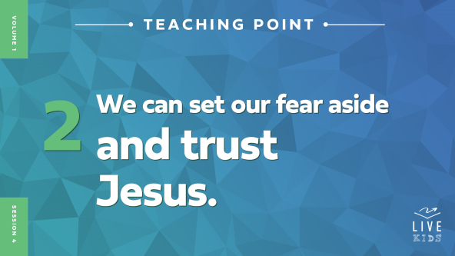

• *Read* [*Matthew 14:24–28*](https://ref.ly/logosref/Bible.Mt14.24-28)*.*

Now we need two of you to act out the next part.

• *Recruit two kids to play Peter and Jesus. Have Jesus stand at the side of the room. Have Peter sit with the rest of the group.*

Everyone else, you’re the disciples sitting in the boat. So the boat started to shake because the wind was blowing like crazy and giant waves were crashing against the boat. The Bible says the disciples were fighting to keep the boat from being tipped over by the waves. I think they were probably scared. Show me what you think their faces looked like. *(Group response)* They were probably freaking out and wondering if they were going to make it out of the storm alive. Then all of a sudden, they looked across the lake and saw Someone walking on the water toward them!

• *Have the Jesus volunteer walk toward the group.*

Now they were *super scared*! Imagine being on that boat with the disciples. The wind is howling. The water is splashing all over the place. The boat is rocking back and forth. And it’s totally dark! Who could that possibly be coming across the water toward them? The disciples thought they were seeing a ghost! I think I might have been scared too!

But then Jesus said, “Take courage, I am here.” It’s like Jesus was saying, “Hey, it’s Me! Don’t be afraid!” What happened next was incredible! Peter said to Jesus, “Lord, if it’s really you, tell me to come to you, walking on the water.” Peter had never walked on water before, of course! But something about seeing Jesus walking on the water made Peter want to do it too. Jesus had never let Peter down before, so Peter had no reason to doubt Him. What do you think happened next? *(Allow responses.)* Let’s keep reading and find out.

**3. Jesus will never let us down.**

• *Show the* ***Teaching Point 3 Slide.***



• *Read* [*Matthew 14:29–33*](https://ref.ly/logosref/Bible.Mt14.29-33)*.*

Jesus told Peter to come to Him on the water, and Peter decided to go for it. He trusted Jesus.

• *Have the Peter volunteer act out the next part as you read.*

Peter stepped out of the boat and started walking on the water toward Jesus! Yay, Peter!

• *Have kids clap for him.*

But then, Peter looked at the big waves and strong wind, and he got really scared. His fear got bigger than his trust in Jesus. He let his fear keep him from walking toward Jesus. And Peter started to sink! Peter shouted for Jesus to save him. And did Jesus do it? *(Group response)* He did! Right away, Jesus reached out His hand and grabbed Peter.

• *Have volunteers act this out.*

When Peter and Jesus climbed into the boat, the wind stopped. The disciples were amazed and worshipped Jesus. They knew for sure that He was the Son of God.

**Prayer and Response**

*Consider playing a worship song softly in the background while kids pray.*

You know, there are times when we get scared just like Peter did.

• *Tell a brief personal story about a time you were scared, preferably as a kid.*

There are lots of things that might make us afraid. I want you to close your eyes right now and think of a time when you were scared. How did you feel? Alone? Angry? Sad? Was it hard to trust the people taking care of you? Was it hard to trust Jesus?

You can open your eyes. Remember, Jesus is always with you, even if you’re scared. Don’t let your fear keep you from trusting Jesus. All you have to do is ask for help and reach out to Him—just like Peter did. Let’s do that now. First, tell Jesus what you’re afraid of. Then ask Him to help you get past that fear.

• *Optional: Invite kids to come forward, so a leader can pray with them about their fear.*

Remember the lesson we learned from Peter. It’s easier to trust Jesus when we keep our eyes on Him. Instead of looking at all the other stuff—like the wind and the waves in Peter’s story—let’s look at Jesus. He is with us. He is for us. And He wants the best for us.

**Prayer**

*Optional: Have the kids repeat phrases of the prayer after you.*

|  |
| --- |
| *Dear Jesus, thank You that I’m never alone. Help me to keep trusting You even if I’m afraid. Amen.* |

**Faith Verse**

Our story reminds me of our Faith Verse, because it talks about looking for Jesus. When we’re afraid, there’s nothing better that we can do. Let’s say our Faith Verse and do the actions together.

• *Play* ***Faith Verse Video****.*

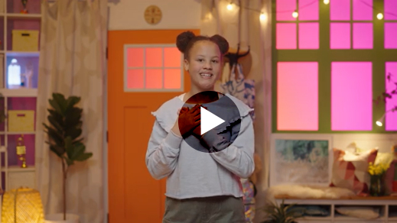

[Jeremiah 29:13](https://ref.ly/logosref/Bible.Je29.13) (NLT)

“If you look for me wholeheartedly, you will find me.”

We really need to know this Bible verse and have it tucked away in our heart and mind. That way, when we’re afraid we’ll remember Jesus is always with us.

**Faith Fact**

Let’s say our Faith Fact again. **I can trust Jesus if I’m afraid.**

• *Show the* ***Faith Fact Slide****.*



Peter trusted Jesus enough to get out of the boat and walk on the water toward Him. That really helps me to know our Faith Fact is true. Say it with me. **I can trust Jesus if I’m afraid.** Say it one more time, and when we’re done, high-five your neighbor. **I can trust Jesus if I’m afraid**. We all get scared sometimes. But let’s remember that we can always trust Jesus.

• *Dismiss kids to Small Group time or to go home if your group time ends here.*

**Small Group**

**30 Minutes**

*This section can be done in conjunction with the large group or on its own if you do small groups with your kids. During Small Group time, the goal is to connect the kids with the Word of God and to each other. All activities are led by the small group leader.*

**Group Connection**

**Trust Fall**

When we’re afraid, it’s not always easy to trust Jesus, but that’s exactly what He wants us to do. So today we’re going to practice trusting each other. Raise your hand if you’ve heard of a trust fall. *(Group response)* One at a time, you’ll stand right in front of me with your back turned toward me. You’ll close your eyes and lean backward. You can trust that I’ll catch you.

• *Ask one kid to demonstrate a trust fall for the group.*

• *Have kids take turns doing the trust fall. Don’t push anyone to do this activity who isn’t comfortable with it.*

• *Repeat the activity with more space between you and the kid if they are willing.*

How did it feel to have to trust that I’d catch you? *(Allow responses.)* Remember, not even Peter was able to trust Jesus all the time. But Peter showed us what to do when we’re afraid. We can call out to Jesus and trust in Him to help us when we’re afraid—just like our Faith Fact says.

**Bible Lesson Recap**

• *If small group activities are not immediately following large group time, you may want to read the Bible story passage before the discussion.*

|  |
| --- |
| ***You Will Need***  *• Bibles for kids in the group to share*  *No prep needed for this activity.* |

**Bible Story Review: Peter Walks toward Jesus on the Water** [**Matthew 14:22–33**](https://ref.ly/logosref/Bible.Mt14.22-33)

In our Bible story, Jesus wanted to pray alone, so He told the disciples to take the boat to the other side of the lake. It got dark, the wind and waves started to pick up, and the disciples got scared. They saw Someone walking on the water toward them, and they thought it was a ghost. But it was Jesus!

Jesus told them to not be afraid. Peter asked Jesus to call him out onto the water. Jesus did, and Peter walked on the water toward Him. But then Peter looked at the waves and wind and got scared again, and he started to sink! So he shouted for Jesus to save him. Jesus reached out and pulled Peter up out of the water. Then they climbed in the boat together, and the wind stopped.

• *Give each kid a Bible and read the Bible story together.*

**Group Discussion**

*Feel free to use all or just a few questions as a jumping-off place for good discussion. Questions marked with * are designed for more conversation. Adjust the questions based on the age or maturity of your group. Typically, older kids will be able to dive a little deeper than younger ones.*

**Questions**

* Why do you think Jesus wanted to be alone to pray? Let’s see if we can name at least five reasons.

*Do you think Jesus knew the wind and waves would scare the disciples? Why or why not?

Why do you think the disciples were worried when they saw Jesus walking on the water?

If you saw someone walking on a lake like Jesus did, how would you react?

What did Peter do that caused him to sink?

* What are some things we can do to trust Jesus more when we’re afraid?

What do you think it was like in the boat after Peter and Jesus climbed in?

* What do you think Peter learned from his experience of walking on the water?

* What can we learn from this Bible story?

**Live It**

**Faith Fact**

Our Bible story is such a great reminder of our Faith Fact: **I can trust Jesus if I’m afraid.** Say it with me with a look of fear on your face. *(Demonstrate fear expression.)* Ready? **I can trust Jesus if I’m afraid.** Now say it again with a look of confidence on your face. **I can trust Jesus if I’m afraid.**

**Challenge**

What are things you can do to trust Jesus if you’re afraid? *(Allow responses.)* The next time you feel scared, say our Faith Fact to yourself. **I can trust Jesus if I’m afraid.** Then do one of these things we just talked about.

**Prayer**

*Finish group discussion by sharing prayer requests and praise reports. Keep track of your small group’s prayer requests and review them each time you meet.*

• *Have kids share and pray for each other’s prayer requests.*

|  |
| --- |
| *Dear Jesus, thank You for always being there for us—when we’re afraid and when we’re confident. Help us to always trust You even if we’re scared. Amen.* |

**Faith Verse Review**

|  |
| --- |
| ***You Will Need***  *• Painter’s tape*  *• Smartphone or timer*  ***Getting Ready***  *• Tape twelve lines (each about 18 inches long) on the floor. Space the lines so they are a kid-sized leap apart.*  *• Optional: Write each word of the verse and the reference on a strip of tape.* |

Our Faith Verse is [Jeremiah 29:13](https://ref.ly/logosref/Bible.Je29.13). Make sure you try to learn it, because you’ll need to know it for our game! Let’s review it together now.

• *Show* ***Faith Verse Video****.*



[Jeremiah 29:13](https://ref.ly/logosref/Bible.Je29.13) (NLT)

“If you look for me wholeheartedly, you will find me.”

**Faith Verse Fun**

**Faith Leap**

Have you heard the phrase “leap of faith” before? *(Group response)* It means trusting something you can’t see or understand and then acting on that trust. In our Bible story, Peter really took a leap of faith when he got out of the boat to walk to Jesus on the water.

We’re going to take leaps too. We’ll divide into two teams. Each team will line up and take turns leaping from one taped line to the next as you say each word of the Faith Verse. I’ll time you to see which team finishes the race the fastest.

• *Divide the group into teams.*

• *Time them as they complete the race.*

• *Congratulate the winning team. Race again if you have time.*

Great job, everyone! I’m so glad we’re learning our Faith Verse. I hope none of us ever forgets it.

**Activity Page**

**Follow Jesus Journal Page**

|  |
| --- |
| ***You Will Need***  *•* ***Small Group Activity Page****, one per kid*  *• Pencils or pens, one per kid*  ***Getting Ready***  *• Print copies of the* ***Small Group Activity Page****, one per kid.* |

On the ***Activity Page***, you can see four footprints across the waves. This represents Peter walking to Jesus on the water. By each footprint, write one thing you can do to have more faith in Jesus and trust Him when you’re afraid.

• *Hand out the* ***Small Group Activity Page*** *and pencils.*

• *Let kids complete the activity.*

• *Have the group share their ideas or review the ideas they shared earlier during the discussion time.*

**Dismissal**

You did a great job today! We learned a lot, and we had fun. Most importantly, I hope you’re leaving here knowing that even if you’re afraid, you can always trust Jesus. He is always with us.

**Prayer**

|  |
| --- |
| *Jesus, we love You. We trust that You will be with us this week as we live out our faith in You. Amen.* |

**Faith Fact Recap**

• *Show the* ***Faith Fact Slide****.*



One last time before you leave, let’s say our Faith Fact. **I can trust Jesus if I’m afraid.** I’m glad you came today. I can’t wait to see you next time!

• *Send home the* ***Small Group Activity Page.***

• *Remind parents that there are* ***Family Devotions*** *available on the app to do with their kid.*

• *Tell everyone the date and time for the next session.*

.